




OPEN ENDED LAB

NAME: GHANIYA USMANI
REG ID#: 27402
ODOO ID#: IU02-0323-0388
COURSE: DATABASE MANAGEMENT SYSTEM (LAB)
COURSE CODE: CSC 331 – L
INSTRUCTOR: MA’M MEHREEN KANWAL

TABLE OF CONTENT
- Cover Page ---------------------------------------------------- 01
- Title Page ------------------------------------------------------ 02
- Table of Content ---------------------------------------------- 03
- Background ---------------------------------------------------- 04
- Theory ---------------------------------------------------------- 04
- Procedure ------------------------------------------------------ 04
- Methodology -------------------------------------------------- 05
- Flowchart ------------------------------------------------------ 05-07
- Analysis (1NF, 2NF, 3NF) ---------------------------------- 07-08
- Discussion on Result --------------------------------- 08
- Limitation ---------------------------------------------- 08
- Future Enhancement --------------------------------- 08
- Conclusion --------------------------------------------- 09
- References --------------------------------------------- 09
- Entity-Relationship Diagram ------------------------ 10-12
- SQL Query Screenshots ------------------------------ 13-22

HOSPITAL MANAGEMENT SYSTEM REPORT
BACKGROUND
Database Management Systems (DBMS) offer a vital part in contemporary medical services through maintaining properly organized information storage, reliable retrieval procedures, and overall information for hospital operations. The Hospital Management System (HMS) database acts as the single database that houses patient-related healthcare professional and monetary information, allowing for effortless communication within hospital divisions.

THEORY
The relational database model has been chosen for this project because of its:
- Data Integrity: ACID principles guarantee dependable transactions.
- Scalability: Capable of managing a growing number of patient records and hospital functions.
- Security: Access control based on roles for confidential medical information.
- Query Efficiency: Designed for handling intricate healthcare queries effectively.
- Normalization: Reduces data duplication and inconsistencies.
- Entity-Relationship Modeling: illustrating entities and their relationships.
- Normalization Principles: Reduces database redundancies by up to 3NF.

PROCEDURE

- Performed analysis to pinpoint patients, doctors, and administrative personnel.
- Recognized entities along with their characteristics.
- Established relationship cardinalities.
- Developed an Entity-Relationship Diagram (ERD) containing 12 entities.
- Determined primary keys for every entity.
- Set up foreign key associations.
- Outlined relationship types (1:1, 1:M, M:N).
- Transformed the ERD into a relational schema.
- Utilized normalization methods.
- Specified data types and established constraints.
- Set up the database in SQL Server.
- Developed all tables with their respective constraints.
- Created indexes to enhance performance.
- Added sample data for each entity.
- Conducted tests on CRUD operations.
METHODOLOGY

- Microsoft SQL Server 2022 is the database.
- Visual Online Paradigm online (ERD) is used as a design tool.
- SQL Server Management Studio is the query interface.
- Microsoft Word is used for documentation.
- Procedure begins using essential entities.
- Implementation of relationship.
- Analysis at every step.
- Evaluation with various queries.

FLOWCHART
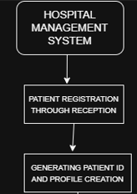
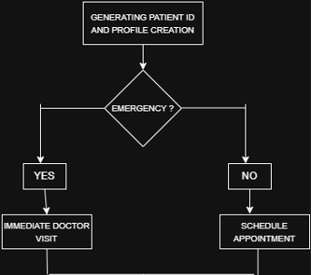

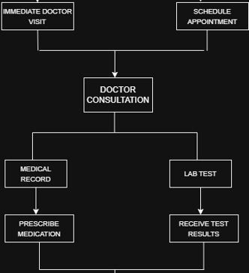
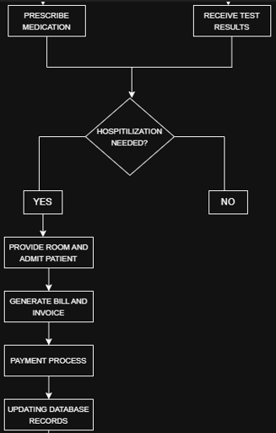

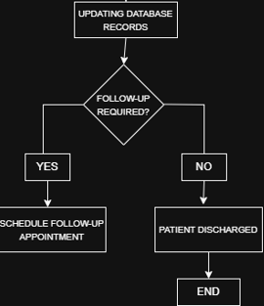

ANALYSIS
- 12 entities include: Hospital, Doctor, Department, Patient, Appointment, Medical Record, Test, Room, Reception, Billing, Payment, and Medication.
- All entities are normalized to third normal form (3NF).
- Data redundancy is achieved.
- No transitive dependencies.
- 11 relationships have been defined in the database schema.
- All tables include primary keys.
- Complex joins have been used.
- ACID compliance has been used for transaction processing.
- It can support multiple hospital branches.
- The database has been designed for more than 10,000 patients.

- FIRST NORMAL FORM (1NF)
- All tables in relational database should have atomic values to be in 1NF.
- Each column contain single value.

- SECOND NORMAL FORM (2NF)
- All non-key attributes are dependent on primary keys.
- There are no partial dependencies.
- Composite keys are managed properly.

- THIRD NORMAL FORM (3NF)
- Transitive dependencies are not present
- All attributes rely on primary keys.
- Primary key constraints are applied on each table.
- Required fields have NOT NULL constraints.
- Foreign key constraint has been properly identified.

DISCUSSION ON RESULT

We have created and executed a comprehensive database for a Hospital Management System that includes:

- 12 well-organized entities addressing all hospital functions.
- Effective normalization to remove data redundancy.
- Patient registration and administration.
- Doctor scheduling and tracking of specializations.
- Appointment management system.
- Maintenance of medical records.
- Ordering tests and tracking results.
- Allocation and management of rooms.
- Billing and processing of payments.
- Monitoring of medication prescriptions.
- Improved queries by implementing appropriate indexing.
- Ensured data integrity with the use of constraints.
- Department heads referencing doctors who are linked to the department.
- Managing date ranges for appointments and admissions.
- Upholding ACID properties in transactions.
- Processing billing and payments.
- Tracking medication prescriptions.

LIMITATIONS
- Limited evaluation options.
- No recovery synchronization implemented.
- Basic security model.
- Important information is not encrypted.

FUTURE ENHANCEMENT
- Integration of telemedicine for virtual consultations.
- Mobile app support for patient portal access.
- AI/ML integration for predictive analytics in patient care.
- IoT integration for collecting medical service data.
- Secure medical record sharing with block chain technology.

CONCLUSION
The database for the Hospital Management System satisfies all requirements and strong database principles. The execution demonstrates:
- Proficient in SQL Server technical skills.
- Capability to create relational databases
- Utilizing advanced database functions.
The database is ready for production and allows for future improvements as the needs of the hospital change.
REFERENCES
- W3Schools SQL Tutorial https://www.w3schools.com/sql/
- Oracle Corporation Database Design Guide https://docs.oracle.com/en/database/oracle/oracle-database/
- Microsoft Corporation SQL Server 2022 https://learn.microsoft.com/en-us/sql/sql-server/?view=sql-server-ver17

ENTITY-RELATIONSHIP DIAGRAM
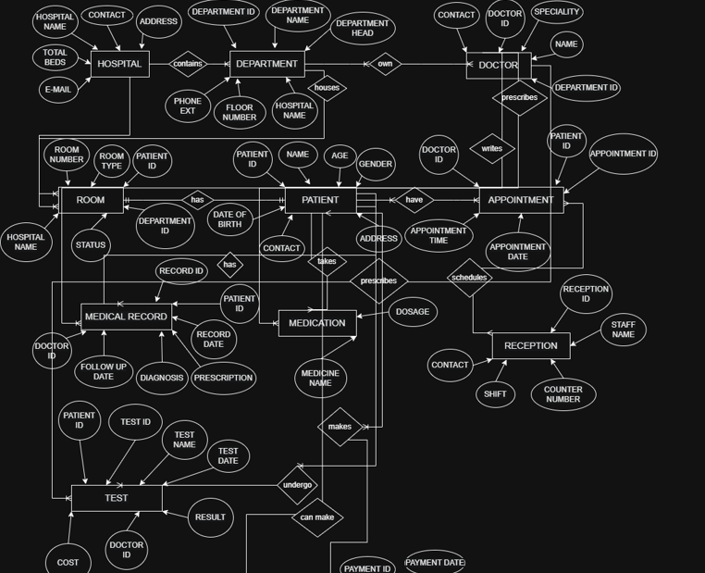

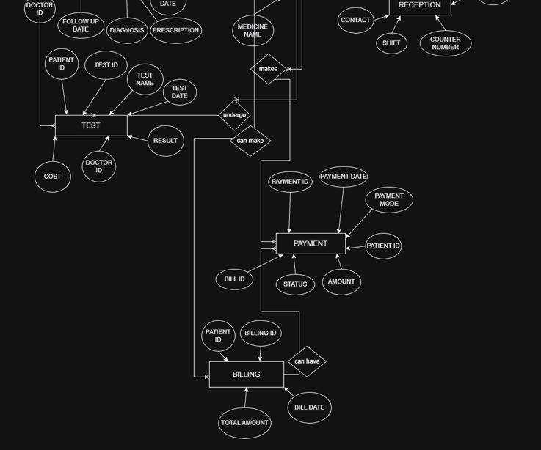
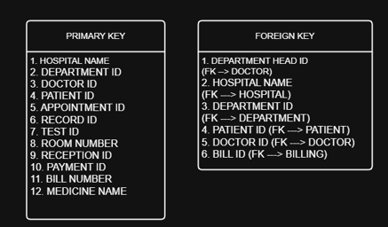
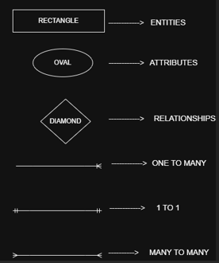

SQL QUERY SCREENSHOTS
